10.1-inch Android rugged tablet (Android 16)
Powerful eight core performance | 1D/2D barcode scanning | Ultimate UHF RFID reading and writing | 10000mAh large capacity battery life
Product Overview
This 10.1-inch Android rugged tablet is a versatile mobile terminal designed for extremely harsh industrial environments. It is equipped with a high-performance MT6789 eight core processor (with a maximum frequency of 2.2GHz) and the Android 13 operating system, providing smooth computing support for complex industrial applications. The device is equipped with a 10000 mAh ultra large capacity polymer lithium battery and supports 30W PD fast charging, ensuring excellent endurance in outdoor or long shift operations.
The most prominent feature of this tablet is its powerful data collection capability. It not only supports optional high-performance 1D/2D barcode scanning, but also optional Built in Impinj E-series chip ultra-high frequency Rfid module, achieving ultra long distance reading of up to 15 meters and group reading efficiency of processing more than 1500 labels every 10 seconds. Its IP67 protection level and anti drop design make it an ideal tool for logistics warehousing, asset management, power inspection, outdoor surveying and other fields.
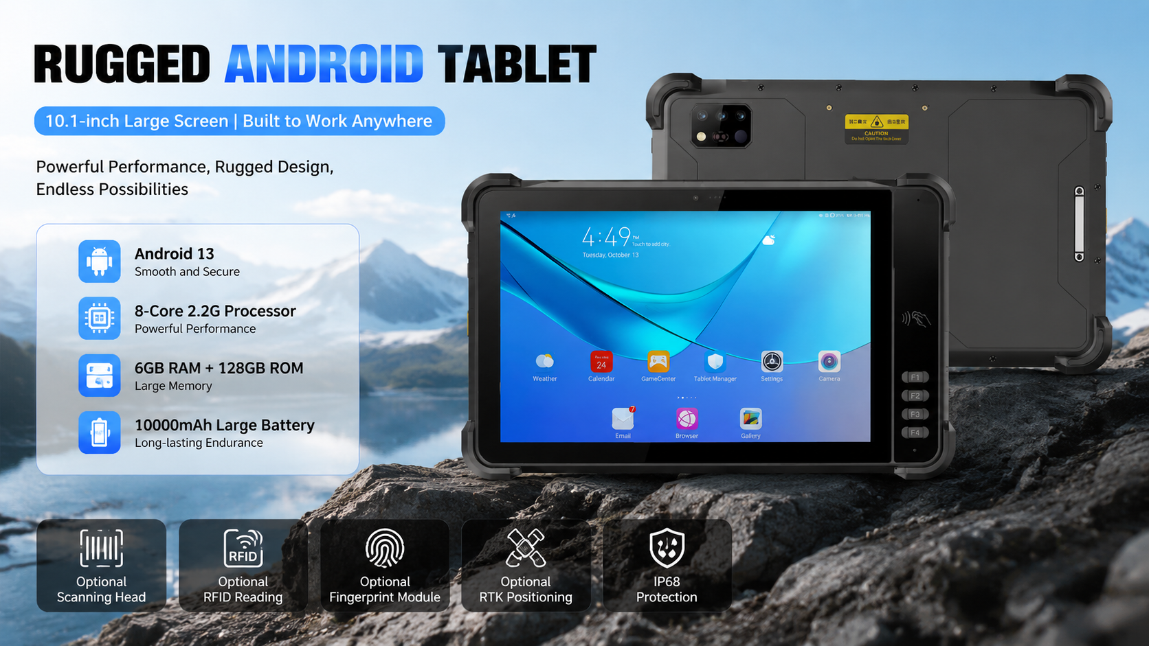
Core strengths
High performance core architecture:
Using MT6789 eight core processor (2x A76 2.2GHz+6x A55 2.0GHz).
Standard configuration includes 8G+128G storage, with up to 8G+256G optional, and supports 512GB memory card expansion.
Excellent data collection capability:
Professional scanning engine: supports mainstream 1D/2D scanning heads (such as E60/N6603, etc.), easily identifying various damaged or low-quality barcodes.
Ultra high frequency RFID (UHF): Built in Impinj E-series chip ultra-high frequency Rfid module, equipped with a 4dBi circularly polarized antenna, the reading distance can reach 15 meters, and the group reading speed is extremely fast (1500+tags/10 seconds).
Full featured NFC: Supports multiple protocols such as ISO14443A/B and ISO15693.
Excellent visibility and interaction:
10.1-inch large screen: standard 800 * 1280 resolution (optional 1200x1920 full HD), supports glove touch.
Multi functional buttons: There are 4 custom function keys on the front and a dedicated scanning key on the side, optimizing one handed operation efficiency.
• Adaptability to harsh environments:
Protection level: up to IP68, dustproof and waterproof.
Drop resistance: able to withstand multiple drops from a height of 1 meter to a cement floor.
Extreme temperature: Supports working environments ranging from -20 ℃ to 55 ℃.
• Comprehensive connectivity capability:
Supports 4G full network, dual band WiFi, Bluetooth 5.0, and multiple satellite positioning systems including GPS and Beidou.
Equipped with a 1600W pixel rear camera that supports high-definition image capture.
Application field
• Warehouse logistics: Efficient automated inventory and remote stacking management for inbound and outbound shipments.
Electricity/oil and gas inspection: It can operate stably even in strong outdoor light or extreme temperature difference environments.
Asset management: Quickly identify thousands of asset tags
Smart transportation: used for vehicle scheduling, road law enforcement, and on-site data transmission.
Summary of Structural Parameters
• Size: 290.6 * 182.5 * 18.5mm
Weight: 980g (standard configuration)
Fast charging: Type-C 30W PD fast charging (can be fully charged in 2-3 hours)

Basic Information
processor | MT6789 (2 Arm) ® Cortex-A76 core, operating frequency of 2.2GHz, 6 Arm ® Cortex-A55 core, operating at a frequency of 2.0GHz
operating system | Android 16
Memory | 8G+128G Optional: 8G+256G
Expand memory | Micro SD card, supports up to 512GB
display | 10.1 inches, resolution: 800 * 1280 550 nits.  Optional: 10.1-inch/1920 * 1200/IPS 600nits/Supports glove mode/wet hand mode
Touch Screen | Capacitive screen: supports multi touch, glove touch
Rear camera | Rear 1600W pixels support autofocus and flash
Front Camera | Front 500W pixel (optional)
audio | Main MIC*1, Noise Reduction and Echo Cancellation*1
audio | Speaker (4W) * 1
prompt | 2 RGB lights
prompt | Vibrating motors
keystroke | Left: Volume +-, Scan key  Right side: Power on button  Front: 4 custom function keys
External interfaces | Left: TYPC-A  Right side: SIM card holder + TF card holder, TYPC-C
Booths | Nano SIM card * 2&Nano SIM card x 1+T_FLASH * 1
sensor | Light sensing+distance, gravity sensor+6-axis gyroscope  optional ： Compass, air pressure sensor
battery | 10000 mAh polymer lithium battery  Standby time> 350 hours  Working time> 10 hours (depending on the usage environment)
Charging method | Type-C 30W PD fast charging  The charging time is 2-3 hours, using the standard power adapter and data cable
Communication Transmission
WLAN function | Dual-band 2.4GHZ/5Ghz, support IEEE 802 a/b/g/n/ac protocol
Bluetooth | Supports Bluetooth 2.1+EDR/3.0+HS/4.1+HS+5.0
GNSS | Supports GPS, Galileo, Glonass, Beidou
Wireless WAN (Data Service) | GSM/GPRS/EDGE/CDMA/UMTS/HSPA/HSPA+/WCDMA/TD-SCDMA/TDD-LTE/FDD-LTE
Wireless WAN (Network Frequency) | 2G：GSM（B2/B3/B5/B8）  3G：WCDMA（B1/B2/B5/B8）  4G：FDD:B1/B2/B3/B5/B7/B8/B20/B25/B26/B28  TDD:B34/B38/B39/B40/B41
Optional functions
Barcode Scanning | 1D code, 2D code scanning head
NFC | Operating frequency: 13.56MHz  Supported Protocols ：ISO14443A/B, ISO15693, NFC-IP1, NFC-IP2  Tag standard: M1 card(S50, S70), CPU card, NFC tag, etc  Reading and writing distance: 1-3cm
UHF RFID | Built in Impinj E-series chip ultra-high frequency Rfid module  North America: 902-928MHz FCC (NA, SA)  Europe: 865-868MHz (ETSI)  China: 920-925MHz (CMIIT)  Full frequency range: 860-960MHz (OPEN )  EPC global UHF Class 1 Gen 2 (ISO 18000-6C)  Antenna:Circular polarization, 4dBi  Up to 15 m (open outdoors, lmpinj MR6 tag)  1500+tags/10sec
Fingerprint module | FAP20 capacitive fingerprint module
Environmental parameters
Operating temperature | -20℃~55℃  *For safety reasons, do not charge in a low temperature environment
Storage temperature | -40°C~70°C (without battery)
humidity | 0~95% (no condensation)
Drop Specs | The 1 meter concrete floor fell many times
Ingress protection | IP67
Electrostatic discharge | ±15KV (air discharge), ±8KV (contact discharge)
Development support
Development language | Java
Develop APIs | Android standard interface
Structural parameters
Dimensions (mm). | 290.6*182.5*18.5mm
Weight as standard | 980g
Equipment accessories
Standard accessories | Adapters, data cables, protective films
Due to irregular product updates, if there are any changes to the content, the actual shipment shall prevail.

Provide ODM and OEM customized services
• We work closely with our partners and can provide various one-stop customized solutions.
• Appearance customization: supports customization of product nameplates, product packaging, and promotional materials.
• Hardware customization: Supports customization of functional modules and optional hardware functions.
• Software customization: supports customization of boot interface, boot program, kernel clipping, and API interface.
• Technical support: Provide SDK development kits and application software development technical services.

